6th Central European Conference 2010 | FIBRE-GRADE POLYMERS, CHEMICAL FIBRES  AND SPECIAL TEXTILES
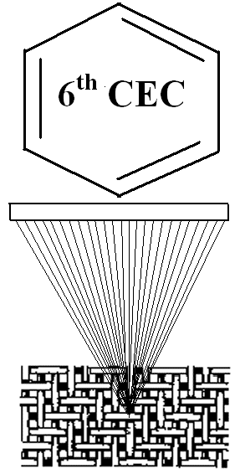  13 - 14 September, 2010  Bratislava,  Slovak Republic | Dear Colleagues  Deadline for sending the full text for 6th Central European Conference is prolonged till 30th June 2010.  Organizing Committee  The link on official websites of 6th Central European Conference is:  http://www.fchpt.stuba.sk/generate_page.php?page_id=2244

