laboratory of Separation processes

Work No. 8

Steady-state distillation and vapour-liquid equilibria of binary mixtures

# IN A TUTSHELL

In the case we want to separate two substances from each other, it is always important to know their physical and chemical properties, based on which we select a suitable separation method. Distillation is a diffusive separation process used to separate components from a homogeneous liquid mixture. The principle of separation is based on the different boiling points of the components being separated at the same pressure (due to their different volatilities). Distillation is advantageous especially when the boiling points of both substances are sufficiently different. From an operational perspective, distillation is divided into continuous and batch distillation. In batch distillation, the raw material is fed into the distillation apparatus once, and during distillation, the temperature, composition of the distillate, and residue are changed. This type of distillation is also called differential distillation, and you can learn more about it in other works. Conversely, in continuous distillation, as the name implies, the raw material is continuously fed into the distillation apparatus, resulting in two streams, distillate, and residue, leaving the apparatus in equilibrium. Therefore, continuous distillation is sometimes also called equilibrium distillation. The composition of the distillate and residue remains unchanged under steady-state conditions during simple equilibrium distillation. If the distillate does not return to the distillation apparatus, this type of steady-state distillation receives another attribute, simple. The disadvantage of simple equilibrium distillation is its limited separation efficiency. If a higher degree of separation is required, it is necessary to add another distillation stage, or rectification columns with reflux of the distillate are used, where almost complete separation of the separated components can be achieved. But this is the subject of another laboratory work, too. The weak separation ability of simple equilibrium distillation is one of the reasons why it is relatively rarely used in industry. Simple distillation is commonly used in oil processing, where it is carried out in a so-called pipe furnace for preparing feed for rectification. The liquid raw material flows through a long pipe heated to a certain temperature. The resulting vapor-liquid mixture is then further directed into the rectification column.

Steady-state distillation has significant utility in measuring equilibrium data. In this laboratory exercise, we will demonstrate how to measure equilibrium data using steady-state distillation and how to work with them further.

# Theory

During steady-state distillation, the feed is continuously introduced into the distillation apparatus with a molar flow rate  and a mole fraction of the more volatile component ** (*Figure* 2). It enters the heat exchanger, where it is first heated to the boiling temperature $t_{B}$, and depending on the heating, the desired distillation temperature $t_{D}$ ​ is reached in a certain part of the heat exchanger, creating an equilibrium vapor-liquid mixture. This mixture then proceeds to the separator, where vapours with a molar flow rate of  and composition ** are separated from the liquid phase, residue, with a molar flow rate of  and composition **. The distillate vapours condense in the condenser to form the distillate. If a total condenser is used (condensing all vapour), the flow rate and composition of the liquid distillate remain unchanged compared to the vapor (**​).

We can observe that in the distillate, compared to the original feed, there is a higher proportion of the more volatile (lower boiling) component. Conversely, in the residue, the proportion of the more volatile component has decreased. The equilibrium composition of the distillate and residue depends on the distillation temperature and the pressure in the system where distillation takes place. In our case, the apparatus is open to the atmosphere, we can only influence the composition of the distillate and residue for a given feed composition by adjusting the distillation temperature. However, the distillation temperature not only affects the composition but also the flow rates of the distillate and residue. This is described by the material balance of the process, the so-called "lever rule," which equalizes the ratios of the lengths of the segments "a" and "b" in the t-x, y diagram in Figure 2 and the ratio of the distillate to residue flow rates. Based on these findings, we can summarize the influence of distillation temperature on the course of equilibrium distillation in one sentence: As the distillation temperature increases, the values of ** and **​ decrease, while the distillate flow rate increases and the residue flow rate decreases.

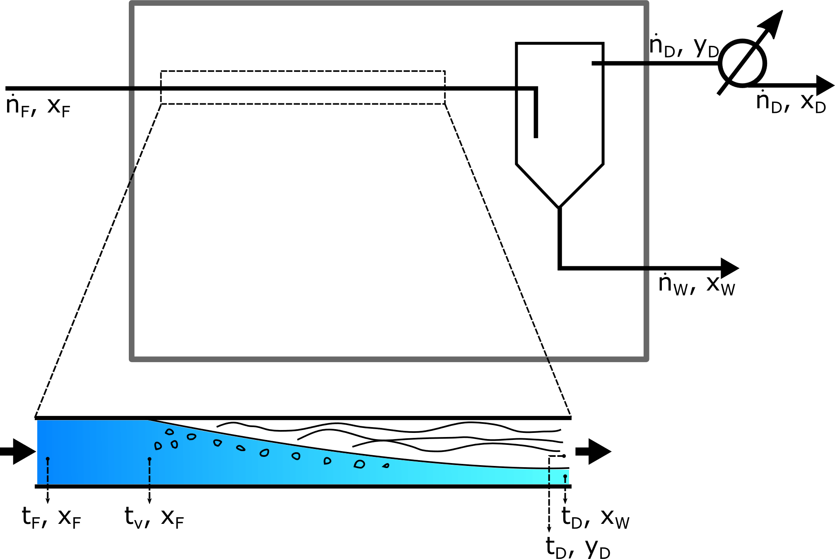

Figure 1 Base scheme of steady-state distillation apparatus. Detailed picture of heat exchanger longitudinal section shows production of steady-state vapour-liquid mixture.

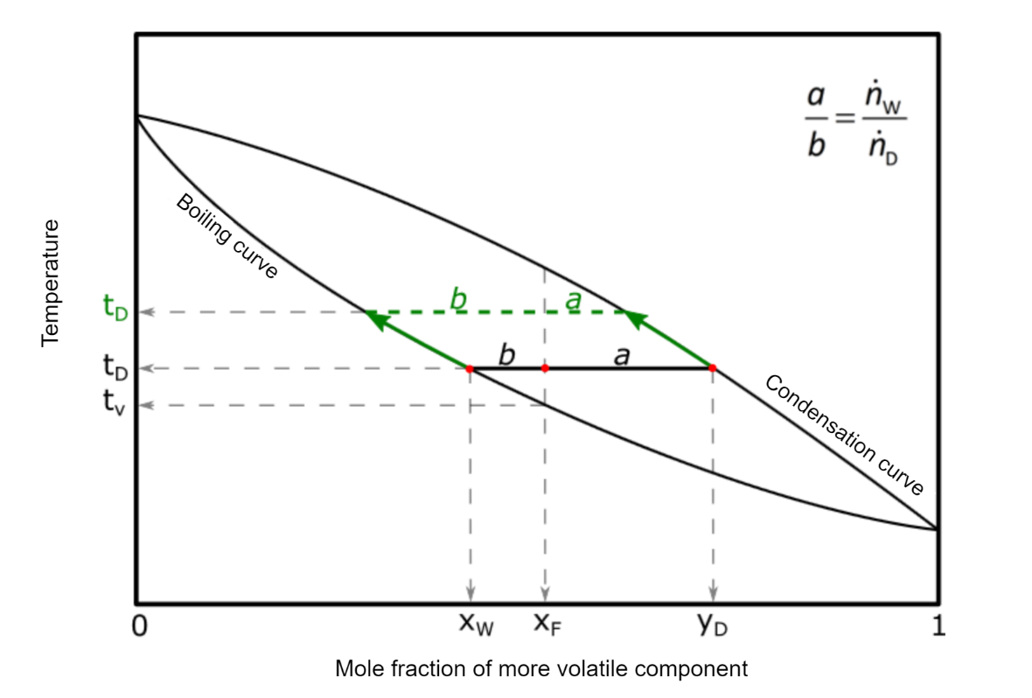

Figure 2 isobaric t-x, y diagram of binary mixture. Green colour represents change of steady-state with higher distillate temperature.

Note: In practice, besides the designation **, representing the more volatile component in the vapours, we may also encounter the designation **. This notation is more suitable for expressing the phase rule of a binary mixture: **. The same statement applies to the notation of the distillation residue.

For equilibrium distillation, material balance equations apply (overall balance and balance for the more volatile component) along with the equilibrium equation.

|  |  |  |
| --- | --- | --- |
|  |  | (1) |
|  |  | (2) |
|  |  | (3) |

In equations (1) – (3), index A corresponds to the more volatile component, and index B corresponds to the less volatile component.  is the equilibrium vaporization coefficient of the component. If the value of the equilibrium coefficient of component *i* is greater than 1, it means that the vapour is enriched with the more volatile component.

Another important parameter is the relative volatility ​, whose value is a measure of the separability of component *i* from component *j*. For distillation to be feasible, the relative volatility must be greater than 1.

|  |  |  |
| --- | --- | --- |
|  |  | (4) |

Under conditions of equilibrium distillation carried out in the laboratory (atmospheric pressure), we will assume approximately ideal behaviour of the vapour phase, while non-ideality in the liquid phase will be quantified using the activity coefficients of individual components. Then, the exact condition of thermodynamic equilibrium between liquid and vapour, expressed by the equality of fugacities of each component in both phases, takes the following form (for a detailed derivation of equation 5, refer to the book "Chemical Engineering II" by Dojčanský, Longauer, pages 150 and 151).

|  |  |  |
| --- | --- | --- |
|  |  | (5) |

where  is the mole fraction in the gas phase and ​ in the liquid phase,  is the vapour pressure of the pure component (calculated at the distillation temperature from the Antoine equation),  is the atmospheric pressure, and ​ is the activity coefficient of component *i* in the liquid phase at concentration ​.

From equation (5), it is evident that for measured equilibrium values, a known distillation temperature, and system pressure, we can calculate the values of activity coefficients ​ from experimental data. These activity coefficients for individual components are not constant but they are a function of composition. For various concentrations of binary mixtures, these dependencies are commonly expressed by van Laar or Margules equations.

* van Laar equations:

|  |  |  |
| --- | --- | --- |
|  |  | (6) |
|  |  | (7) |

* Margules equations:

|  |  |  |
| --- | --- | --- |
|  |  | (8) |
|  |  | (9) |

Coefficients A, B characteristic for a given mixture, and for our purposes, we will consider them to be constant throughout the entire range of component concentrations, independent of temperature.

# OBJECTIVES of the work

1. Determine the equilibrium composition of the distillate and residue of a binary mixture at two different distillation temperatures.
2. Calculate the values of activity coefficients and determine the optimal values of A and B for van Laar or Margules equations.
3. Graphically compare the equilibrium curves calculated using the calculated values of coefficients A and B for van Laar or Margules equations with literature data in the t-x, y diagram.

# ASSIGMENT OF THE WORK

1. Measure the equilibrium composition  and  of the binary mixture methanol-isopropanol for:
2. for …………. at the temperature ………… °C
3. for …………. at the temperature ………… °C
4. Determine coefficients A and B for van Laar or Margules equations from two measured equilibrium data pairs  and  and approximately 8 additional values obtained from chemical engineering tables and calculate their average.
5. Calculate the optimal values of coefficients A and B for van Laar or Margules equations. Use both optimal and non-optimal coefficient values to compute the equilibrium t-x, y diagram and compare it graphically with the diagram drawn based on equilibrium data provided in chemical engineering tables.
6. Graphically illustrate the dependence of  and  on the mole fraction of the more volatile component .
7. For the value $=$ …, provide a detailed calculation of the equilibrium value of using the optimal coefficient values A and B.

# Apparatus description

The diagram of the apparatus for equilibrium distillation is shown in Fig. 2. It consists of two storage tanks (1) in which the raw material is located. Using a peristaltic pump (2), the raw material is dosed into a spiral tube, which is immersed in the tempered water bath of the thermostat (3). By passing through the tube, the raw material is heated, partially vaporized, creating an equilibrium vapor-liquid mixture. We read the distillation temperature on the thermometer (4) (the digital temperature indicator (3b) indicates the temperature of the water bath). The pipe leads to a phase separator with a siphon, from which the liquid residue leaves. The vapors naturally leave the upper part of the separator and proceed to the condenser (5), where they condense completely. The distillation residue is cooled in the heat exchanger (6). Samples are taken from collection tubes using syringes.

Figure 3 Scheme of the equipment for equilibrium distillation. 1 – storage bottle for raw material, 2 – peristaltic pump, 3 – thermostat, 3a – thermostat main switch, 3b – bath temperature display, 3 – bath temperature setting, 4 – thermometer indicating distillation temperature, 5 – distillation vapor condenser, 6 – cooler of distillation residue, 7a – sampling of distillation residue, 7b – sampling of distillate, 8 – collection container.

# WORK PROCEDURE

## safety measures

1. During work, especially when handling samples, caution must be exercised as the substances being worked with are highly flammable class 1 materials, and methanol is a dangerous poison!

## Preparation for measurement

1. Familiarize ourselves with the equipment and verify its completeness according to the documentation provided for the experiment. Request the assignment and approval to start the measurements from the lab teacher. Prepare the digital refractometer for measurement.
2. Measure the refractive index of the raw material using the refractometer and calculate its precise composition based on the calibration curve.
3. Introduce cooling water into the condensers (5, 6) for cooling (at an appropriate flow rate) and switch on the thermostat (3). Set the temperature on the thermostat using the t-x, y diagram and the determined composition of the raw material. The desired temperature is the one at which segments *a* and *b* In Fig.2 have the same length.
4. Fill the raw material into the flask and switch on the pump.

## MEasurement

1. We find out the value of atmospheric pressure from the laboratory barometer and record it in Table 1.
2. Once the temperature in separator stabilizes for 5 to 10 minutes, we begin to collect samples of both distillate and residue. Distillate and residue are collected simultaneously.
3. Allow approximately 5 ml of sample to flow into the syringe and measure the refractive index of the distillate and residue using a refractometer. Repeat sampling and refractive index measurement 4 more times at approximately 3-minute intervals. Throughout the measurement, monitor the distillation temperature on the thermometer, which will also be recorded in Table 1.
4. Using the calibration curve (APPENDIX), determine the mole fraction of the more volatile component in the sample from the measured refractive indices (*yD*​ or *xW*). Record the measured values in the prepared Table 1, as well as the calculated average values of the distillation temperature and mole fraction of the more volatile component in the distillate and residue. If any of the measured values deviate significantly from the others, repeat the corresponding measurement.
5. Turn off the pump to conclude the first measurement.
6. Similarly, prepare the apparatus for the next measurement with the second raw material and follow steps 1 through 5. Record the measured data in Table 2.

## Ends of measurement

1. We will stop the supply of raw material. Turn off the thermostat and stop the water supply to the condensers (5, 7).

# Questions – what could ask you a teacher before the experiment

* What is steady-state distillation?
* Describe individual parts of apparatus.
* Provide a brief description of the measurement, what you are going to measure, and how you will proceed?

# PROCESSING OF MEASURED DATA

## determination of experimentAL aND CALCULATED ACTIVITY COEFICIENTS (Table 3)

1. In the first two rows of Table 3, enter the average values of the experimentally measured distillation temperature, mole fractions of the distillate, and residue. Complete the data for the next eight rows from tabulated information (chemical engineering tables, page 73) of the equilibrium of the binary mixture of methanol-isopropanol to cover the range of mole fractions from 0 to 1.
2. For each temperature, calculate the saturated vapor pressures of methanol and isopropanol using the Antoine equation:

|  |  |  |
| --- | --- | --- |
|  |  | (10) |

1. From equation (5) calculate the value of the activity coefficients for each equilibrium data point, denotes as  and . These values of activity coefficients will be considered as experimental in subsequent calculations.
2. Subsequently, for each pair of experimental  and  values, we calculate the coefficients A and B using modified van Laar equations (11), (12) and Margules equations (13), (14).

* van Laar equations:

|  |  |  |
| --- | --- | --- |
|  |  | (11) |
|  |  | (12) |

* Margules equations:

|  |  |  |
| --- | --- | --- |
|  |  | (13) |
|  |  | (14) |

1. From the calculated values of parameters A and B, we compute the average values. These values are then copied into the row with title *Optimized*.
2. Parameters A and B will be used to calculate the activity coefficients, this time directly from the van Laar equation (6), (7) or the Margules equation (8), (9). These values of activity coefficients will be considered as calculated.
3. For each row of the table, we calculate the square of the deviation between the calculated and measured values of activity coefficients.

|  |  |  |
| --- | --- | --- |
|  |  | (15) |

1. In the same column, we compute the sum of squares of deviations between calculated and experimental values of activity coefficients. This cell is also called as the objective function.

|  |  |  |
| --- | --- | --- |
|  |  | (16) |

1. We optimize the values of coefficients A and B using a nonlinear optimization method to minimize the objective function. We recommend using MS Excel for optimization:

* In Excel, under the *"Data"* tab, you will find the *"Solver"* function. A window named *"Solver Parameters"* will appear. In the *"Set Objective"* field, enter the coordinates of the cell corresponding to the objective function. In the next row labelled *"Equal to"* select *"min"* for minimum. In the *"Changing Cells"* row, select the cells of the optimized coefficients A, B. Then click on *"Solve"*. The resulting parameters A and B will be the optimized parameters of the equations.

1. We plot graphs showing the dependence of the calculated activity coefficients , resp.  from the van Laar or Margules equation on the mole fraction of the more volatile component in the residue.

## Calculation of steady-state vapour-liquid data (Tab. 4)

1. In the first column in Table 4, we choose twelve values of  in the range 0-1 (we can use the same values like in Chemical-engineering tables, page 73).
2. We calculate the mole fraction of the less volatile component 
3. In the next steps, we will need the equilibrium temperatures for calculation. We do not know their values in advance, so we can use data from tables for estimation. These temperatures will be used to calculate the saturated vapour pressures for components *A* and *B*.
4. We calculate values of activity coefficients from van Laar (6), (7), resp. Margules (8), (9) equations. During their calculation, we use the optimized parameters *A* and *B*.
5. We calculate the values of the mole fractions in the vapour phase  a  from equation (*5*).
6. In the last column, we will define the objective function for each row:

|  |  |  |
| --- | --- | --- |
|  |  | (17) |

1. Through iterative calculation, we will optimize the estimated temperatures to satisfy the objective function (17). For this purpose, we will again use the solver function in MS Excel. However, this time we use it for each row separately.
2. In Excel, under the *"Data"* tab, locate the *"Solver"* function. The *"Solver Parameters"* window will appear. In the *"Set Target Cell"* field, enter the coordinates of the cell corresponding to the objective function. In the next row labelled *"Equal to"*, select *"Minimum"*. In the *" Changing Cells"* row, select the temperature value for the respective row. Then click *"Solve"*, and you will obtain the optimized temperature value. Repeat this calculation for each row separately.
3. We will repeat the calculation from points 3 to 8 also for the non-optimized average values of parameters *A* and *B*.
4. We will construct a t-x, y diagram from tabulated values (page 73), from calculated values (Table 4) where optimized as well as non-optimized parameters *A* and *B* were used.
5. Začiatok formulára

# TABles

Tab. 1 Experimental data for mixture xAF=.....

|  |  |  |  |  |  |
| --- | --- | --- | --- | --- | --- |
| *P*atm = | (Pa) |  |  |  |  |
| Measurement | *t* (°C) | refractive index (W) | refractive index (D) | *x*W=*x*AW | *y*D=*y*AD |
| 1 |  |  |  |  |  |
| 2 |  |  |  |  |  |
| 3 |  |  |  |  |  |
| 4 |  |  |  |  |  |
| 5 |  |  |  |  |  |
| Median value |  |  |  |  |  |

Tab. 2 Experimental data for mixture xAF=.....

|  |  |  |  |  |  |
| --- | --- | --- | --- | --- | --- |
| *P*atm = | (Pa) |  |  |  |  |
| Measurement | *t* (°C) | refractive index (W) | refractive index (D) | *x*W= *x*AW | *y*D= *y*AD |
| 1 |  |  |  |  |  |
| 2 |  |  |  |  |  |
| 3 |  |  |  |  |  |
| 4 |  |  |  |  |  |
| 5 |  |  |  |  |  |
| Median value |  |  |  |  |  |

Tab. 3 Determination of experimental and calculated activity coefficients (Notice: create table in MS Excel environment)

|  |  |  |  |  |  |  |  |  |  |  |  |  |
| --- | --- | --- | --- | --- | --- | --- | --- | --- | --- | --- | --- | --- |
|  |  |  |  |  |  | Experimental | |  |  | Calculated | |  |
| Measurement | *t* (°C) | *y*A | *x*A |  |  |  |  | *A* | *B* |  |  | Deviation |
| 1. |  |  |  |  |  |  |  |  |  |  |  |  |
| 2. |  |  |  |  |  |  |  |  |  |  |  |  |
| 3. |  |  |  |  |  |  |  |  |  |  |  |  |
| 4. |  |  |  |  |  |  |  |  |  |  |  |  |
| 5. |  |  |  |  |  |  |  |  |  |  |  |  |
| 6. |  |  |  |  |  |  |  |  |  |  |  |  |
| 8. |  |  |  |  |  |  |  |  |  |  |  |  |
| 9. |  |  |  |  |  |  |  |  |  |  |  |  |
| 10. |  |  |  |  |  |  |  |  |  |  |  |  |
|  |  |  |  |  |  | Average/not optimized | |  |  |  | UF |  |
|  |  |  |  |  |  | Optimized | |  |  |  |  |  |

Tab. 4 Calculation of steady-state data liquid-vapour (Notice: create table in MS Excel environment)

|  |  |  |  |  |  |  |  |  |  |  |
| --- | --- | --- | --- | --- | --- | --- | --- | --- | --- | --- |
| N° | *x*A | *x*B | *t* (°C) |  |  |  |  | *y*A | *y*B | UF |
| 1. |  |  |  |  |  |  |  |  |  |  |
| 2. |  |  |  |  |  |  |  |  |  |  |
| 3. |  |  |  |  |  |  |  |  |  |  |
| 4. |  |  |  |  |  |  |  |  |  |  |
| 5. |  |  |  |  |  |  |  |  |  |  |
| 6. |  |  |  |  |  |  |  |  |  |  |
| 7. |  |  |  |  |  |  |  |  |  |  |
| 8. |  |  |  |  |  |  |  |  |  |  |
| 9. |  |  |  |  |  |  |  |  |  |  |
| 10. |  |  |  |  |  |  |  |  |  |  |
| 11. |  |  |  |  |  |  |  |  |  |  |
| 12. |  |  |  |  |  |  |  |  |  |  |

# Appendix

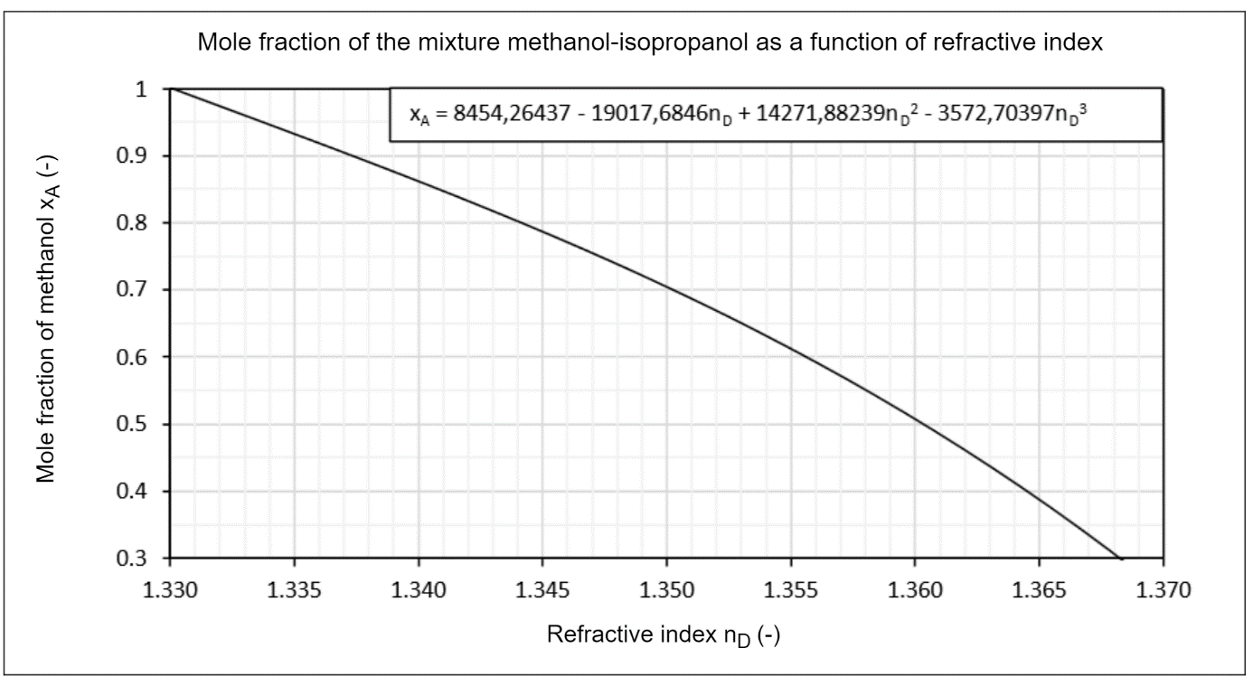

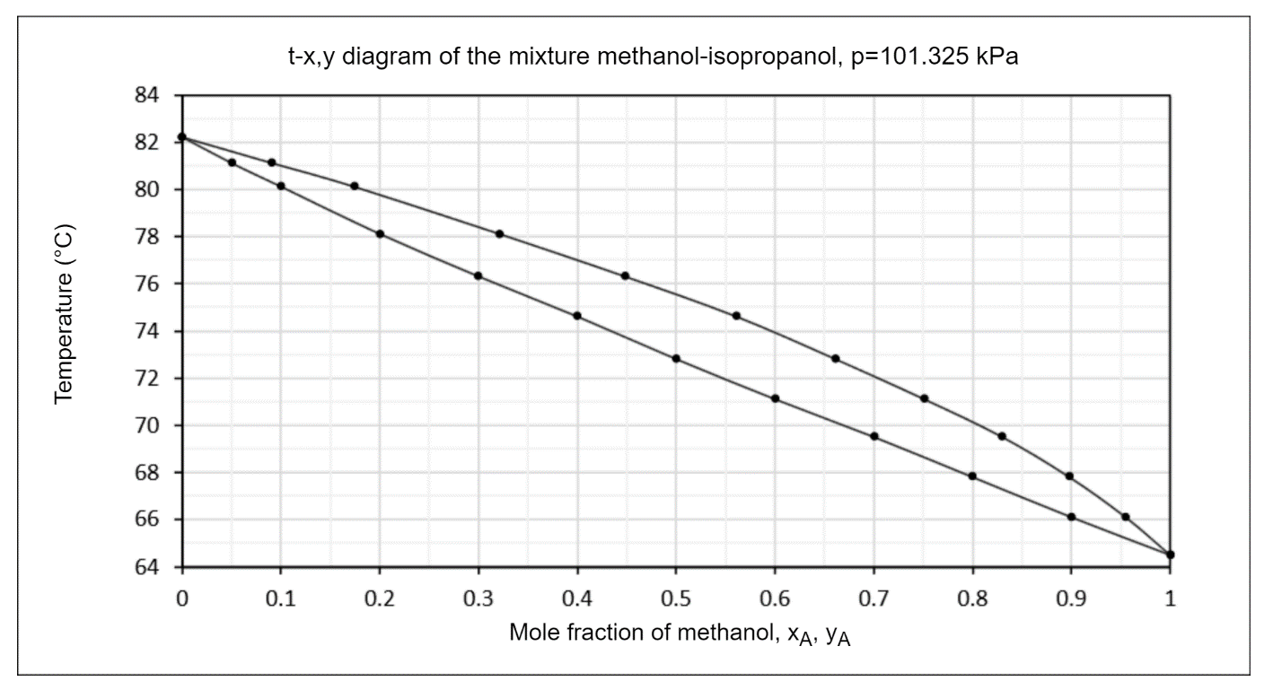

## USER MANUAL FOR THE DIGITAL REFRACTOMETER KRÜSS DR301-95

1. Connect the device to the power supply.
2. Press the ON/OFF button.
3. Open the cover and clean the prism (if necessary).
4. Place approximately 3-4 drops onto the prism, ensuring that the entire surface is covered with liquid, and be careful of air bubbles.
5. Close the cover.
6. Press the READ/ENTER button.
7. The refractive index will be displayed on the screen.
8. Clean and dry the prism with a cotton swab.
9. The device is ready for further measurements.
10. After finishing, turn off the refractometer by pressing the ON/OFF button and disconnect the device from the power supply.