LABORATORY OF SEPARATION PROCESSES

Excercise n.15

Differential rectification in a packed column

# In a nutshell

Distillation is a diffusive separation process, through which it is possible to separate individual components of a homogeneous liquid mixture based on their different boiling temperatures, or respectively, different volatilities. The oldest distillation processes are batch, differential distillation, and simple, continuous distillation. In both cases, only limited separation can be achieved. By using the distillate as a raw material in further distillation stages, higher purity of the resulting distillate can be achieved (Figure 1 A). A drawback of such multi-stage distillation is relatively low yield and high energy consumption because the cooled liquid distillate must be brought back to boiling and partially evaporated again. Yield has been increased by recycling the waste (Figure 1 B), and energy consumption has been reduced by utilizing energy (enthalpy) from the vapor of the preceding stage - tray (Figure 1 C).

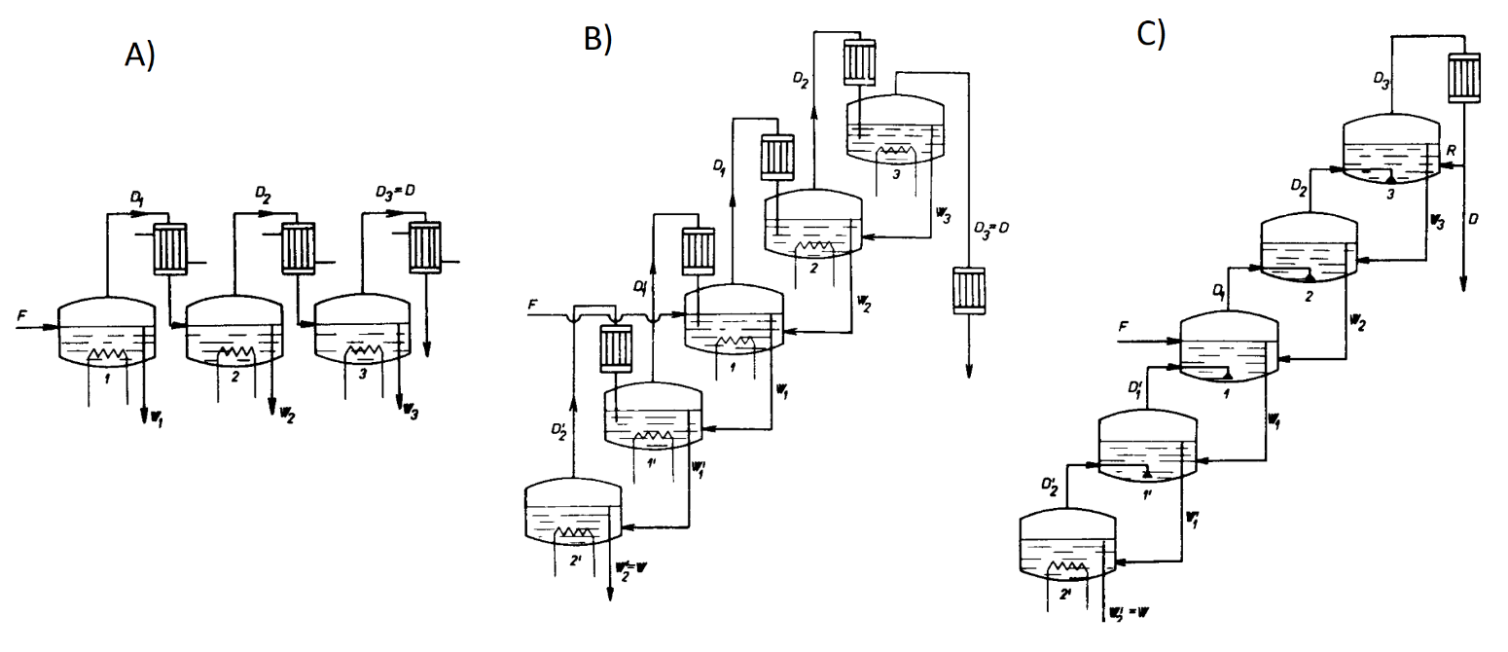

Figure 1 A) Multi-stage distillation without utilizing wastes. B) Multi-stage distillation with utilization of wastes. C) Multi-stage distillation with utilization of residues and vapor enthalpy = tray rectification.

Such multi-stage distillation with countercurrent flow of liquid and vapor is called rectification, and the device in which it takes place is a rectification column. The energy required to generate vapor is supplied to the reboiler at the bottom of the rectification column, vapor from the top stage condenses in the condenser, and some of it returns as reflux to the top stage.

When vapor flowing upward through the stages contacts the liquid flowing downward to the bottom of the column, into the reboiler, there is a two-way mass transfer, accompanied by heat exchange and partial condensation, preferably transferring less volatile components from vapor to liquid and partially evaporating more volatile components from liquid to vapor. This process enriches the vapor with more volatile components as it passes through the column.

Efficient enrichment of vapor with more volatile components requires intensive contact between the vapor and liquid phases. Various types of internals or fillings in rectification columns serve to achieve the necessary phase contact. In packed columns, the required phase contact is achieved through column packing, along which the liquid phase flows in a thin layer while vapors from the reboiler flow countercurrently. Different types of packing differ in specific surface area, which also determines the height of the column required to achieve the desired separation of the feedstock. (Figure 2).

Figure 2 Packed rectification column with various types of fillings.

While in trayed devices, the composition of vapor and liquid changes "step by step" from one tray to another, in packed columns, the composition of vapor and liquid changes continuously. By increasing the number of trays, or increasing the height of the packing in the rectification column, we also increase its separation efficiency. In rectification columns, we can influence the separation efficiency by changing the reflux ratio, which expresses the ratio of the molar flow of condensed vapor returned back to the column (reflux) to the molar flow of distillate taken from the column.

Rectification columns can be designed for both continuous and semi-continuous processes. In continuous rectification columns, the feed is continuously introduced into the column, typically through a feed nozzle. Distillate is withdrawn from the top of the column (the highest tray), and the residue is taken from the reboiler, with their compositions and molar flows remaining constant over time (they are in a steady state). In semi-continuous rectifications, the feed is introduced into the reboiler once, distillate is withdrawn from the top of the column, and the waste remains in the reboiler. In this case, it is a form of differential rectification because either the composition or the flow rate of the distillate changes over time. If during differential rectification, we maintain a constant reflux ratio, then the composition of the distillate will change over time. An example of differential rectification with a constant reflux ratio is the distillation of alcohols from natural sources (such as agave). During the process, fractions of distillates are collected at specified temperature intervals corresponding to certain concentrations of distilled components. These fractions are then blended in appropriate proportions to create distillates with desired sensory properties. If constant distillate composition is desired during differential rectification, then the reflux ratio must be adjusted over time, which poses a non-trivial requirement from a process control perspective.

# THEORY

Rectification in a packed column is a countercurrent separation process in which a vapor stream is partially generated by evaporation of the mixture in the reboiler. This stream ascends through the packing of the rectification column, where it comes into contact with the descending liquid phase. The surface of the packing creates a large interfacial area over which the liquid phase flows, and the surface must be thoroughly wetted by the liquid. Upon contact between the phases, the vapor stream is enriched with the more volatile component of the mixture being separated, leading to a change in their compositions. The vapor stream exiting the top of the column enters the condenser. A portion of the condensate returns to the column as reflux liquid. The separation of components in the liquid mixture in the rectification column results from a complex process of partial evaporation and partial condensation with simultaneous intensive heat transfer between the two phases. Intensive phase contact in the column is achieved through various column internals or packing. When the column is filled with solid bodies or structured packing, it is referred to as a packed column.

Differential rectification is a batch, semi-continuous process because the feed is introduced into the reboiler only once, and its quantity is not replenished during rectification. Upon column startup, vapor is continuously withdrawn from the condenser, and distillate is the only exiting material stream. The process of differential rectification is unsteady, with the composition of phases changing at different points in the column over time. Since distillate, i.e., a stream with a higher content of the more volatile component compared to the composition of the liquid in the reboiler, is removed from the device, the content of this component in the column steadily decreases.

When setting up the material balance of a differential rectification, we must consider the balancing period. If we only consider the initial and final states, the overall material balance and material balance of the more volatile component are expressed by the equations:

|  |  |  |
| --- | --- | --- |
|  |  | (1) |
|  |  | (2) |

where  epresents the material quantity of the mixture and  is the mole fraction of the more volatile component in the feed (F), distillate (D), and bottoms (W).

The relationship between the quantities of individual streams and their compositions in the case of differential rectification also affects the separation efficiency of the column. The greater the separation efficiency of the column, the more the instantaneous composition of the distillate , differs from the composition of the waste .

In the form of a differential equation, the material balance in the enriching section of the rectification column is described by the equation:

|  |  |  |
| --- | --- | --- |
|  |  | (3) |

By combining equations (1) and (2), we obtain:

|  |  |  |
| --- | --- | --- |
|  |  | (4) |

In the case where we are only interested in tracking the change in the composition of the distillate during the course of the differential distillation, by appropriately adjusting, we can modify the differential form of the material balance of the more volatile component as follows:

|  |  |  |
| --- | --- | --- |
|  |  | (5) |

This equation represents the material balance of the more volatile component, which is valid at every moment of rectification. The amount of substance of the more volatile component in the feed (left-hand side of the equation) must equal the sum of the amount of substance of the more volatile component in the distillate, which we have distilled up to the given time (first term on the right-hand side), and amount of substance of the more volatile component in the waste, which at that moment is in the reboiler. The distilled quantity of the more volatile component is calculated by integrating the instantaneous quantities of the more volatile component in the various fractions of the distillate.

Figure 3 The representation of the instantaneous composition of the distillate  and waste during differential rectification in a column operating at a reflux ratio R and the method of subtracting the number of theoretical stages.

Similarly to the case of a tray column, we can express the relationship between the instantaneous composition of the liquid phase xL and the vapor phase yG at any cross-section of the rectification column.

For this purpose, we use the operating line equation derived from the material balance of the more volatile component in the given cross-section of the column.

|  |  |  |
| --- | --- | --- |
|  |  | (6) |

where *R* is the reflux ratio, defined as the ratio of the material flow rates of the reflux liquid and the distillate

|  |  |  |
| --- | --- | --- |
|  |  | (7) |

Equation (6) was derived under the simplifying assumptions used in the graphical design method of distillation columns (McCabe–Thiele), i.e., equality of vapor enthalpies of components of the feed mixture, equality of their heat capacities, and negligible mixing enthalpy. The equation applies to the entire enriching section of the packed rectification column from its top (point D = [; ]) to the bottom part of the packing. Here, vapors from the reboiler, which are in equilibrium with the composition of the waste , come into contact with the liquid phase flowing into the reboiler. In the equilibrium y–x diagrame (Figure 3) this point corresponds to point N = [; ]. The equation (6) in the equilibrium diagram is represented by a line with a slope of R/(R + 1).

When designing a packed column, it's necessary to know the packing height at which the desired separation efficiency (sharpness of separation) is achieved. In practice, a parameter called the Height Equivalent to a Theoretical Plate (HETP) is used for this purpose. HETP represents the packing height at which the same enrichment of vapor with the more volatile component is achieved as in the case of a theoretical plate. A theoretical plate in a rectification column represents a stage where the phases leaving the stage are in equilibrium. Empirical calculation equations are available to compute the HETP, taking into account parameters such as vapor mass flow density, relative volatility of components, as well as the density and viscosity of the descending liquid phase. The packing height of the rectification column is calculated from the known number of theoretical plates (NTP) and the value of HETP as their product.

|  |  |  |
| --- | --- | --- |
|  |  | (8) |

The number of theoretical plates, in accordance with the graphical method for designing rectification columns by McCabe and Thiele, corresponds to the number of right-angle steps we construct between the operating line and the equilibrium curve in the equilibrium y−xy−x diagram (Figure 2). The last right-angle step between the equilibrium curve and the operating line, which is depicted in this figure (from point N to W), corresponds to the separation effect of the reboiler.

During differential rectification, the content of the more volatile component in the distillation residue continuously decreases. This means that with unchanged separation efficiency of the column, the content of the more volatile component in the distillate also decreases. The separation efficiency of the column can be increased to some extent by increasing the reflux ratio, i.e., by reducing the amount of distillate withdrawn. In this case, the slope of the operating line increases, allowing us to obtain a concentrated more volatile component in the distillate even with a lower content in the reboiler.

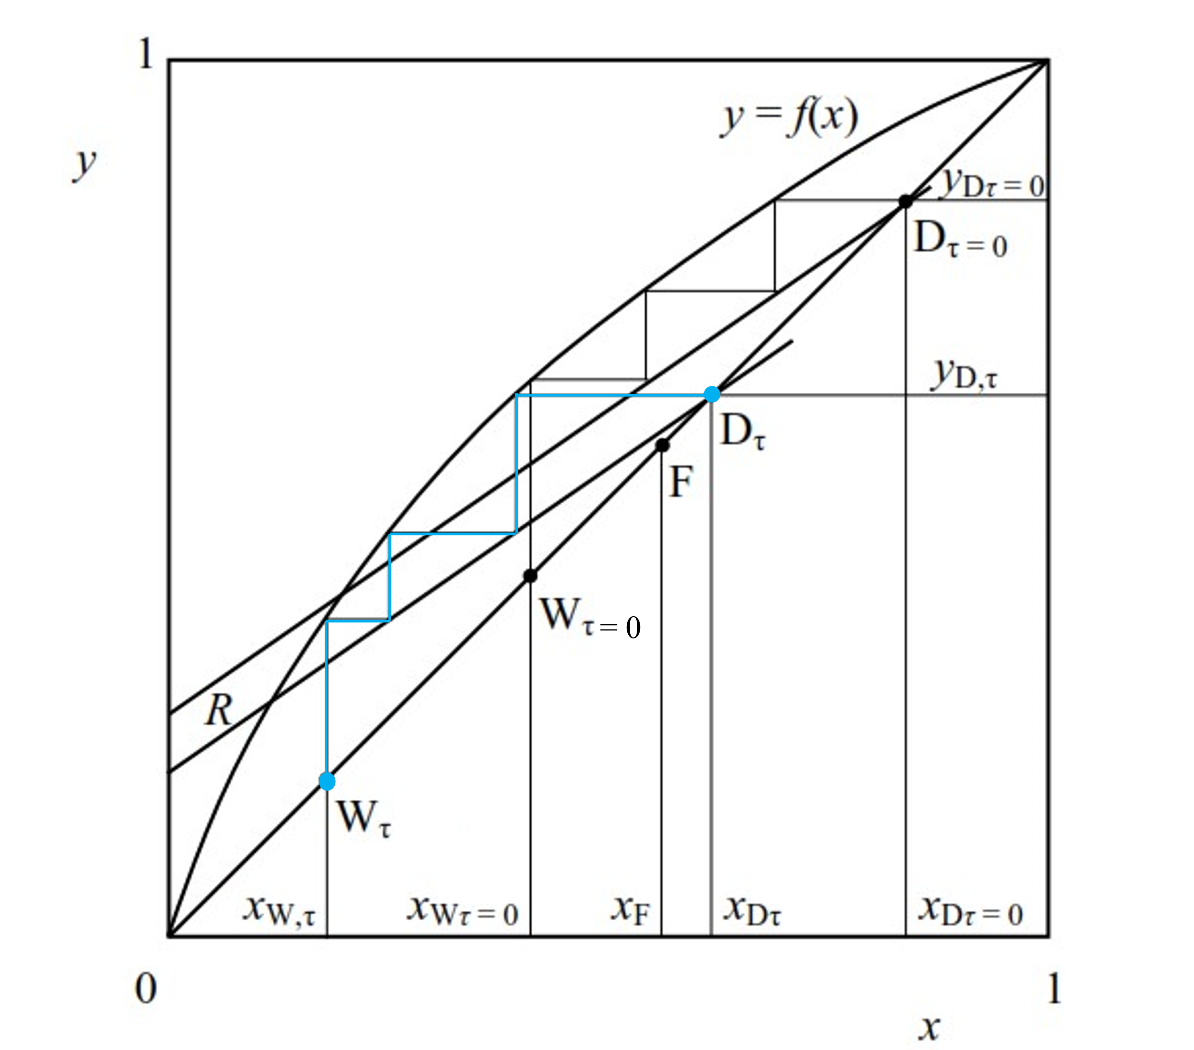

Figure 4 Representation of the instantaneous composition of the distillate, , and the waste, , at the beginning of the differential rectification (τ = 0) and at the time τ in the column (in blue), which operates at a constant reflux ratio, R.

If the differential rectification is carried out at a constant reflux ratio, the slope of the operating lines (R/(R + 1)) remains unchanged for different moments of the process, causing the content of the more volatile component in the distillate to decrease over time. On Figure 4, two operating lines are depicted on the equilibrium y-x diagram, representing the instantaneous material balance of the more volatile component in the column under conditions at the beginning of rectification (τ = 0) and at time τ ≠ 0 (blue). As visible, they are parallel lines intersecting the diagonal of the equilibrium diagram at the point corresponding to the current composition of the distillate. The composition of each stream continuously changes during rectification. In the case of the distillate, the content of the more volatile component decreases from the initial valueto  and the content of the more volatile component in the distillation residue changes from  through to . The composition of the distillate obtained throughout the entire rectification process, as well as the residue, can be calculated by solving equations (1), (2), and (5).

# OBJECTIVES OF THE WORK

Determine the value of the height equivalent to a theoretical plate of a laboratory packed column.

# WORK ASSIGNMENT

In the packed column with a diameter of Dc = 30 mm, separate ... mol of a binary mixture of methanol - ethanol so that at the end of the distillation, you have 200 ml of distillate. Compare the theoretical and experimentally determined value of the height equivalent to a theoretical plate of the packed rectification column.

# EQUIPMENT DESCRIPTION

Figure 5 Diagram of the packed rectification apparatus for the fractional distillation of binary mixtures.

1 – boiler (distillation pot), 1a – cooling coil, 1b – inlet of cooling water, 1c – outlet of cooling water, 1d – filling valve, 1e – temperature sensor (temperature in the boiler), 1f – safety relief valve, 1g – outlet of vapor, 1h – discharge valve of distillation residue, 1i – reflux return, 2 – induction heating, 3a – collection flask for measuring reflux (39,7 ml), 3b – valve for measuring reflux, 4 – packed column with a diameter of 30mm, 4a – temperature sensor (temperature at the head of the column), 5 – total condenser, 5a – inlet of cooling water, 5b – outlet of cooling water, 6 – peristaltic pump for reflux, 7 – overflow flask, 8 – valve for switching between settling mode and fraction collection, 9 – valve for switching between two sampling flasks, 10 a,b – three-way valves for sample collection, 11 – Erlenmeyer flask for collecting distillate, 12 – control panel, 12a – main switch, 12b – wattmeter, 12c – heating switch, 12d – heating program, 12e – heating regulation, 12f – display of temperature in the boiler (thermometer TR), 12g – display of temperature at the column head (thermometer TH), 13a – main valve of cooling water, 13b – branch of cooling water to the condenser, 13c – valve of cooling water to the cooling coil of the boiler.

# WORK PROCEDURE

## SAFETY MEASURES

During sampling, it is important to realize that we are working with boiling liquid. Moreover, we are working with flammable substances, the vapors of which can be harmful to health.

## PrEPARATION FOR MEASUREMENT

Note: Record all parameter values mentioned in parentheses in Tab. 1.

1. Familiarize yourself with the equipment and check its completeness. Prepare the digital refractometer for measurement.
2. Calculation of the volume of raw material for distillation:

Take a sample of the raw material and measure its refractive index . Determine the mole fraction of the more volatile component in the raw material from the calibration graph in the documentation . Furthermore, it is necessary to measure the temperature of the raw material  , and from these two data points of the raw material, determine the molar volume of the raw material ( Graph in the APPENDIX). With the known molar volume, it is possible to easily calculate the amount of raw material in terms of volume , required to be poured into the distillation pot.

|  |  |  |
| --- | --- | --- |
|  |  | (11) |

1. The correctness of the calculation will be checked by the exercise instructor.
2. Check if the boiler (1) is empty. Fill the boiler vessel (1) with the raw material through the filling opening (1d).
3. Check if the valve (1d) and the valve (1h) are closed.
4. Set the valve (8) to the settling mode, where we return the distillate to the boiler.
5. Open the main valve for the inlet of cooling water (13a), thereby allowing cooling water into the condenser (5). Check if the valve for cooling water to the boiler is closed (13c).
6. Turn on the main power switch (12a) to supply electricity to the laboratory equipment. Turn on the induction heating, press button (12c), set the heating program (12d), and set program P5 with buttons (12e).
7. After the first drops of condensate appear at the bottom of the column, change the heating program to P3.
8. Once liquid distillate appears at the outlet of the condenser, turn on the peristaltic pump for reflux with the switch. Wait for another 15 minutes for the system to stabilize in the column, during which all the distillate returns through the valve (8) to the boiler.
9. Request permission to start the measurement.

## MEASUREMENT

Note: Record all parameter values mentioned in parentheses in Tab. 1.

1. As defined in the assignment, we will collect the volume of the total distillate in ten aliquot portions.
2. We initiate the distillate collection by rotating the valve (8) to the vertical position (Subsequently, we do not manipulate this valve further). After collecting each portion of the distillate, we determine its composition by measuring the refractive index of the sample  and converting it to a mole fraction. With each collection, we record the temperature in the boiler  and at the column head . During the collection of three portions of the distillate, we also note the time it takes for the syringe  to fill up and record the temperature of the distillate  (ideally at the beginning, middle, and end of the measurement). We accumulate the distillate fractions in an Erlenmeyer flask.
3. During the collection of distillates, we need to measure the reflux three times (ideally at the beginning, middle, and end of the measurement). For this purpose, we close the valve (3b) and record the time, it takes for the collection flask (3a) to fill up to the upper edge (its volume is 39.7 ml). Then we reopen the valve (3b) so that the reflux can continue back into the boiler.
4. After collecting the tenth portion of the distillate volume, we switch the valve (8) to the horizontal position and turn off the induction heating of the boiler with button (12c).
5. We only turn off the peristaltic pump when it has pumped out all the liquid from the overflow flask (7).
6. We let cooling water into the cooling coil of the boiler through the valve (13c), wait until the temperature in the boiler drops to 40°C. By opening the valve (1h), we drain the distillation residue into a receiving vessel, determine its refractive index  and calculate the mole fraction of the more volatile component in the residue . Using a measuring cylinder, we measure the volume of the residue .
7. We take a sample from the total distillate, determine its refractive index and calculate the mole fraction of the more volatile component . Using a measuring cylinder, we measure the volume of the distillate .
8. We pour the total distillate and the distillation residue into a measuring cylinder; we should obtain the same volume as the volume of the raw material.

## END OF MEASUREMENT

We stop the flow of cooling water and turn off the laboratory equipment with the main switch.

## IF YOU WISH TO REVIEW THE EQUIPMENT DESCRIPTION AND THE PROCEDURE, YOU CAN FIND IT IN THE VIDEO:

<https://www.youtube.com/watch?v=0SPIM9cry_8&list=PL81QAQg818vjDK7pm9WO6tW36sdBpPGYa&index=3>



# QUESTIONS – what the teacher may ask you before the experiment

* Describe the individual parts of the experimental apparatus.
* Explain what you will measure, how, and why.

# ANALYSIS OF MEASURED DATA

All values mentioned in parentheses will be recorded in Tab. 2.

1. We will calculate the average temperature of the distillate .
2. For each composition of the distillate fraction, we will subtract from the graph (APPENDIX) the value of the molar volume  of the respective mixture at the average temperature of the distillate. By using Equation (11), we will calculate the removed amounts of substance of the distillate fractions .
3. According to Equation (12), we will calculate the total amount of distillate present in the Erlenmeyer flask at that moment.

|  |  |  |
| --- | --- | --- |
|  |  | (12) |

1. From the material balance equation (1), we will calculate the instantaneous value of the amount of substance of the residue for each row of the table.

|  |  |  |
| --- | --- | --- |
|  |  | (13) |

1. We will calculate the average composition of the distillate present in the Erlenmeyer flask at that moment for each row as:

|  |  |  |
| --- | --- | --- |
|  |  | (14) |

1. From the material balance of the more volatile component (2), we will calculate the instantaneous value of the composition of the residue present in the boiler at that moment for each row of the table.

|  |  |  |
| --- | --- | --- |
|  |  | (15) |

1. We will calculate the reflux ratio for three measurements.

|  |  |  |
| --- | --- | --- |
|  |  | (16) |

where the molar volumes will be determined from the equation in the appendix. For the distillate at the average distillate temperature  and composition  in the respective measurement. For the reflux at the boiler temperature  and composition in the respective measurement.  (39,7 ml) is the volume of the reflux collection flask, and  (20 ml) is the volume of the distillate sampling flask. We will further use the average value of the reflux ratio in the calculations .

1. In the equilibrium y-x diagram, for each distillate fraction, we will mark the instantaneous composition of the distillate , and the waste, . For each distillate composition, we will construct operating lines with a slope of R/(R + 1), intersecting the diagonal of the equilibrium diagram at the respective points  (Figure 4). Between each operating line and the equilibrium dependence, we will draw perpendicular steps corresponding to the number of theoretical plates in the column plus one (the last step corresponds to the enrichment of vapor with the more volatile component in the boiler).
2. From equation (8), we will determine the experimental value of the height equivalent to a theoretical plate (HETP) for each distillate fraction. From the individual values of HETP, we will calculate the average value of HETP.
3. To calculate the value of the height equivalent to a theoretical plate, use the equation:

|  |  |  |
| --- | --- | --- |
|  |  | (17) |

where h = 0.95 m is the height of the packing layer in the column. Determine the relative volatility of the mixture as well as the density and viscosity of the liquid phase at the boiling temperature of the raw material. Calculate the density of the mass flow rate of vapor  from the measured flow rates.

|  |  |  |
| --- | --- | --- |
|  |  | (18) |

1. In Tab. 3, we will summarize the experimental and calculated values of HETP, as well as the compositions of the distillate and residue at the end of distillation, and determine the relative deviation according to the equation:

|  |  |  |
| --- | --- | --- |
|  |  | (19) |

# TABLES

Tab. 1 Recording of measured data.

|  |  |  |  |  |  |  |  |  |
| --- | --- | --- | --- | --- | --- | --- | --- | --- |
|  |  |  |  |  |  |  |  |  |
|  |  |  |  |  |  |  |  |  |
|  |  |  |  |  |  |  |  |  |
| Measurement |  |  |  |  |  |  |  |  |
| 1 |  |  |  |  |  |  |  |  |
| 2 |  |  |  |  |  |  |  |  |
| 3 |  |  |  |  |  |  |  |  |
| 4 |  |  |  |  |  |  |  |  |
| 5 |  |  |  |  |  |  |  |  |
| 6 |  |  |  |  |  |  |  |  |
| 7 |  |  |  |  |  |  |  |  |
| 8 |  |  |  |  |  |  |  |  |
| 9 |  |  |  |  |  |  |  |  |
| 10 |  |  |  |  |  |  |  |  |
|  |  |  |  |  |  |  |  |  |
|  |  |  |  |  |  |  |  |  |

Tab. 2 Calculated data

|  |  |  |  |  |  |  |  |  |
| --- | --- | --- | --- | --- | --- | --- | --- | --- |
|  |  |  |  |  |  |  |  |  |
| Measurement |  |  |  |  |  |  |  |
| 1 |  |  |  |  |  |  |  |
| 2 |  |  |  |  |  |  |  |
| 3 |  |  |  |  |  |  |  |
| 4 |  |  |  |  |  |  |  |
| 5 |  |  |  |  |  |  |  |
| 6 |  |  |  |  |  |  |  |
| 7 |  |  |  |  |  |  |  |
| 8 |  |  |  |  |  |  |  |
| 9 |  |  |  |  |  |  |  |
| 10 |  |  |  |  |  |  |  |
|  |  |  |  |  |  |  |  |

Tab. 3 Results of the evaluation of measured data.

|  |  |  |  |  |  |
| --- | --- | --- | --- | --- | --- |
| Experimental data | | Calculated data | | Comparison | |
|  |  |  |  |  |  |
|  |  |  |  |  |  |
|  |  |  |  |  |  |

# APPENDIX

Obrázok, na ktorom je text, rad, vývoj, diagram

Automaticky generovaný popis

Obrázok, na ktorom je text, rad, vývoj, diagram

Automaticky generovaný popis

Obrázok, na ktorom je text, rad, vývoj, diagram

Automaticky generovaný popis

## USER MANUAL FOR THE USE OF DIGITAL REFRACTOMETER KRÜSS DR301-95

1. Connect the device to the power supply.
2. Press the ON/OFF button.
3. Open the lid and clean the prism (if necessary).
4. Drop about 3-4 drops onto the prism so that the entire surface of the prism is covered with liquid, be careful of bubbles.
5. Close the lid.
6. Press the READ/ENTER button.
7. The refractive index will be displayed on the screen.
8. Clean and dry the prism with a cotton swab.
9. The device is ready for further measurements.
10. After finishing, turn off the refractometer with the ON/OFF button and disconnect the device from the power supply.